DYNAMIC PREFIX PARITY

A PROJECT REPORT

Submitted by

BHARANI SREE B.
RAKCHITHA M.
SHINMAYA K.B.

(Reg. No. 9517202306016)

(Reg. No. 9517202306079)

(Reg. No. 9517202306091)

in partial fulfillment for the award of the degree

of

BACHELOR OF TECHNOLOGY

in

INFORMATION TECHNOLOGY



DEPARTMENT OF INFORMATION TECHNOLOGY MEPCO SCHLENK ENGINEERING COLLEGE, SIVAKASI
(An Autonomous Institution affiliated to Anna University Chennai)

November 2024

Register No: .………………………
CERTIFICATE

This is to certify that it is the Bonafide work done by Bharani Sree B.(9517202306016),Rakchitha.M(9517202306079),ShinmayaK.B
(9517202306091) for the 23IT353 - Mini Project - I work entitled “Dynamic Prefix Parity“ at Department of Information Technology, Mepco Schlenk Engineering College, Sivakasi during the year 2024 – 2025.

…………………………… ……………………………
FacultyIn-Charge Head of the Department

Submitted for the Practical Examination held at Mepco Schlenk Engineering College, Sivakasi on ……………………….

…………………………. …………………………
Internal Examiner - I Internal Examiner - II

ABSTRACT

ABSTRACT

The Dynamic Prefix Parity (DPP) problem involves designing an efficient data structure to maintain an array of n bits with three operations: initialize (set all bits to 0), flip(toggle the i-th bit), and Prefix-parity (compute the parity of the first i bits). Parity is defined as 0 for an even number of 1s and 1 for an odd number.Augmented Binary Trees: The initial solution employs a binary tree where each node stores cached parity information of its sub-tree. This ensures that initialize runs in O(n), while both flip and Prefix-parity execute in O(log n), leveraging efficient updates and traversal.Augmented Multi-way Trees: Extending to multi-way trees with a branching factor b, the operations are optimized further. The runtime for flip is reduced to O(log n), and Prefix-parity executes in O(log n), while retaining O(n) for initialize. Each node manages cached parity for multiple children, enabling high performance.Method of Four Russians: This advanced optimization uses precomputation of all possible sub-problem solutions to achieve O(log n) time for flip and Prefix-parity. By dividing the problem into smaller parts and leveraging array-based lookup, this method balances preprocessing cost and query efficiency.

TABLE OF CONTENTS

CHAPTER 1 | INTRODUCTION | 1
1.1 | AIM | 2
1.2 | OBJECTIVE | 2
1.3 | AUGMENTED MULTI WAY TREE | 2
1.4 | PREFIX-PARITY | 2
1.5 | FLIPPING BITS USING XOR | 3
1.6 | DIVIDE AND CONQUER ALGORITHM | 5
1.7 | RECURSIVE TRAVERSAL | 5

CHAPTER 2 | PROBLEM STUDY |  |  | 10
2.1 | SCOPE |  |  | 11
2.2 | SCOPE APPROACH |  |  | 11
2.3 | GOALS |  |  | 12
2.4 | LANGUAGE USED
2.5 | COMPILER USED
2.6 | COMPARSION

CHAPTER 3 | DIFFERENT APPROACHES |  |  |  |  |  |  | 14
3.1 | OVERVIEW |  |  |  |  |  |  | 15
3.2 | MODULES |  |  |  |  |  |  | 15
 |  | 3.2.1 | INITIALIZATION |  |  |  | 15
 | 3.2.2 |  | FLIP FUNCTION |  |  |  | 16
 | 3.2.3 |  | PREFX PARITY CALCULATION |  |  |  |  | 17
CHAPTER 4 | IMPLEMENTATION |  |  |  |  |  |  |  | 19
4.1 | STANDARD LIBRARIES |  |  |  |  |  |  |  | 19
4.2 | INITIALIZATION |  |  |  |  |  |  |  | 20
4.3 | FLIP |  |  |  |  |  |  |  | 20
4.4 | ALGORITHM AND FLOWCHARTS
CHAPTER 5 | RESULTS AND DISCUSSION |  |  |  |  |  |  |  | 22
5.1 | SCREENSHOTS 23
CHAPTER 6 | CONCLUSION |  |  |  |  |  |  |  |  | 27
6.1 | CONCLUSION AND FUTURE ENHANCEMENT |  |  |  |  |  |  |  |  | 28
CHAPTER 7 | APPENDIX |  |  |  |  |  |  |  |  | 35
7.1 | CODE |  |  |  |  |  |  |  |  | 36
CHAPTER 8 | REFERENCES |  |  |  |  |  |  |  |  | 37
8.1 REFERENCE 46
CHAPTER 9 REAL TIME APPLICATIONS

9.1 | APPLICATION

INTRODUCTION

CHAPTER 1

INTRODUCTION

  - AIM
To develop an efficient data structure for the Dynamic Prefix Parity (DPP) problem, optimizing initialization, bit flipping, and prefix parity queries using augmented trees and precomputation.

  - OBJECTIVE
- Design a data structure to efficiently handle dynamic prefix parity operations on an n-bit array.

- Support initialize to set all bits to 0 in O(n)time.

- Optimize the flip operation to toggle any bit efficiently.

- Enhance the prefix-parity query to calculate parity of the first iii bits in reduced time.

1.3 Augmented Multi-way Tree
A multi way tree is a tree where each node can have multiple children (more than two), enabling a more balanced structure compared to binary trees.

An augmented multi-way tree includes additional information (metadata) in its nodes to optimize specific operations.

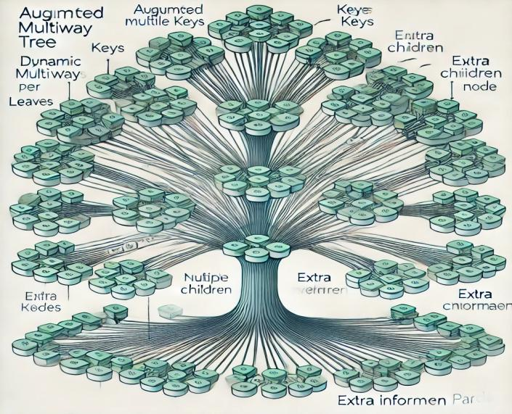

Properties of a Multi way Tree
A multi-way tree is a generalization of a binary tree where each node can have more than two children. Below are its key properties:
1.Variable Number of Children:
2.Balanced or Unbalanced

- Parent-Child Relationship

- Depth and Heigh

- Generalization of Binary Trees

- Efficient Traversals

- Dynamic Partitioning

- Height Efficiency

9.Caching and Augmentation

Applications:
Multi-way trees are widely used in:
- Databases: B-trees and B+ trees for indexing.
- File Systems: Hierarchical data structures.
- Compression Algorithms: Huffman trees for variable-length encoding.

  - Prefix-Parity

Parity, in computing, is a simple error-detection scheme that involves adding an extra bit to a binary code.
How it Works:
· Even Parity: The parity bit is set to 1 if the number of 1s in the data is odd, and 0 if it's even.
· Odd Parity: The parity bit is set to 1 if the number of 1s in the data is even, and 0 if it's odd.

1.4 Flipping bits using XOR
The XOR (exclusive OR) operator is a logical operation that takes two inputs and produce an output of 1 only if the inputs are different.

0 XOR 0 = 0
0 XOR 1 = 1
1 XOR 0 = 1
1 XOR 1 = 0
- When we perform a bitwise XOR with a number and 1, it flips each bit of the number. This is because:
If a bit is 0, XOR with 1 flips it to 1.
If a bit is 1, XOR with 1 flips it to 0.

1.5 Divide-and-Conquer
Divide and conquer is an algorithmic technique used to solve problems by breaking them down into smaller sub-problems.
These sub-problems are solved independently and then combined to form the solution to the original problem.
Three Key Steps:
- Divide
- Conquer
- Combine

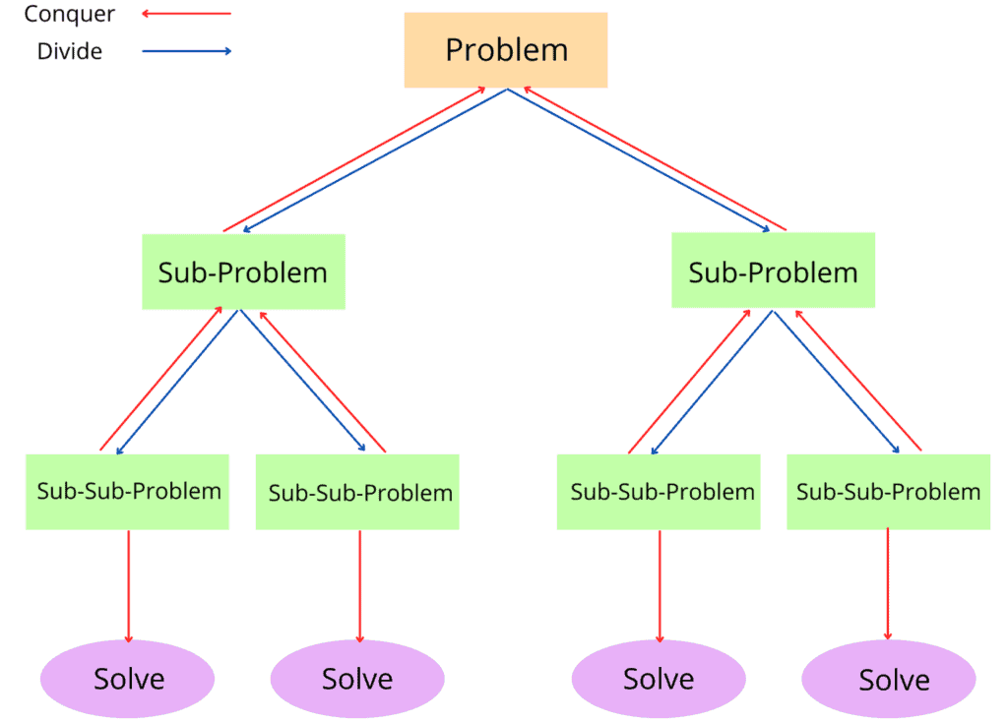
- Break the problem into smaller sub-problems, which are similar to the original problem but with a reduced size.
- Solve each of the sub-problems recursively. If the subproblem is small enough, solve it directly (often referred to as the "base case").
- Combine the solutions of the sub-problems to obtain the solution to the original problem.

Advantages of Divide and Conquer

- Efficiency:
  - Reduces the time complexity for many problems (e.g., logarithmic algorithms).
- Parallelism:
  - Independent sub-problems can be solved in parallel.
- Scalability:
  - Works well for large datasets and recursive structures.

1.6 Recursive Traversal

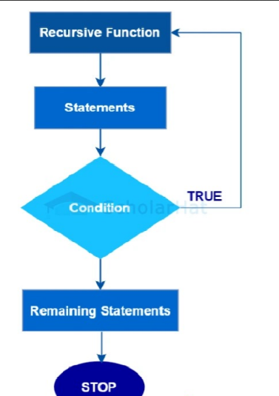

- The provided code demonstrates recursive traversal for a Dynamic Prefix Parity (DPP) problem.
- The initialize function recursively builds a multiway tree to represent the XOR of subarrays.
- The prefix_parity function uses recursion to compute the parity of a subarray by traversing the tree.
- The flip function recursively flips a specific bit and recalculates the XOR for the affected subtree, adjusting parent node values.
- Main application:Divide and conquer Algorithm

PROBLEM STUDY

CHAPTER 2

PROBLEM STUDY

2.1 SCOPE

The scope of the Dynamic Prefix Parity (DPP) problem lies in efficiently managing dynamic

bit arrays with operations that involve Prefix Parity Calculation,Bit Flips,Data Structure

Design,Optimized Performance.

2.2 SCOPE APPROACHES
1. Initialization
- Step 1: Start by initializing the bit array with all bits set to 0.
- Step 2: Create a tree structure (multi way tree) to represent the bit array and calculate the parity for sub-arrays.
- Step 3: For each node in the tree, store the XOR (parity) of the corresponding range of bits

2. Flip Operation
- Step 1: Identify the bit at the given index to flip.
- Step 2: Change the bit from 0 to 1 or from 1 to 0.
- Step 3: Update the parity values for all the parent nodes in the tree that are affected by the flip.

3.Prefix Parity Calculation
- Step 1: To calculate the prefix parity up to a given index
- Step2: find the XOR of all bits from index 0 to the specified index.
- Step 3: Traverse the tree and combine the XOR values from the relevant nodes.
- Step 4: Return the final XOR value, which is the prefix parity up to the specified index.

Range Parity Calculation

function prefixParity(A):
n = length(A)
parityArray = new array of size n
parityArray[0] = A[0]
for i = 1 to n-1:
parityArray[i] = parityArray[i-1] ^ A[i] return parityArray
Expected outcome for this pseudocode:
parity-array[0] = A[0] = 1
parity-array[1] = parityArray[0] ^ A[1] = 1 ^ 0 = 1
parity-array[2] = parityArray[1] ^ A[2] = 1 ^ 1 = 0
parity-array[3] = parityArray[2] ^ A[3] = 0 ^ 1 = 1
The prefix parity array is [1, 1, 0, 1].

2.3 GOALS
1.Efficiently calculate the prefix parity (XOR of bits) for any subarray in an array of bits.
Real time applications:
- Network Traffic Monitoring
- Cryptography
- Error Detection

- Allow efficient updates (flipping a bit) while maintaining the ability to quickly compute updated prefix parities for any sub array.
Real time applications:
- Dynamic Data Structures in Databases
- Fault Tolerance in Distributed Systems

2.4 LANGUAGE USED

C++ - Object-Oriented Programming (OOP)
C++ is a powerful, high-level, and general-purpose programming language developed by Bjarne Stroustrup at Bell Labs in the early 1980s. As an extension of the C programming language, C++ incorporates object-oriented programming (OOP) principles, making it suitable for a wide range of software development tasks, from system programming to game development,C++ supports the principles of OOP, including encapsulation, inheritance, and polymorphism. This allows developers to create classes and objects, promoting code reusability and modularity.
2.5 COMPILER USED
MinGW (Minimalist GNU for Windows)
MinGW is a lightweight development environment designed for compiling C, C++, and other programming languages on Windows. It provides a minimalist set of tools, including the GNU Compiler Collection (GCC), enabling the creation of native Windows applications.
MinGW offers a simple, efficient way to develop applications without the need for a large integrated development environment (IDE). By leveraging the power of the GNU tools and GCC, MinGW allows developers to build and run software natively on Windows while maintaining compatibility with Unix-like environments. It’s widely used for porting software to Windows and developing cross-platform applications.

2.6 COMPARISON

Aspect | Initialize | Flip | Prefix-parity
Purpose | Builds the multiway tree to represent the bit array and precomputes prefix parities | Updates a specific bit in the array and propagates the changes through the tree. | Computes the cumulative XOR (prefix parity) up to a given index in the bit array.
Input Parameters | - Start (beg) and end(end) indices.  - Range of the bit array. | - Start (beg) and end (end) indices.  - Index of the bit to flip.  - New value to XOR. | - Start (beg) and end (end) indices.  - Target index for prefix parity calculation.
Output | Returns the root node of the constructed multiway tree. | Returns the updated tree node with recalculated parity values. | Returns the cumulative XOR (parity) for all elements from the start up to the target index.
Operation Type | Recursive tree construction (Divide and Conquer). | Recursive update with XOR operation and recalculation of parent parity values. | Recursive traversal to calculate prefix parity based on XOR values.
When It's Called | Once at the beginning to initialize the tree for a given array size. | Whenever a bit in the array needs to be flipped. | Whenever a prefix parity query is made.
Complexity | Time: O(n * log n), where n is the array size (due to tree construction). | Time: O(log n), since updates propagate through the tree. | Time: O(log n), as queries traverse the tree.
Key Operation | Recursive division and construction using XOR. | XOR operation to flip a bit and update parent nodes. | XOR operation to aggregate prefix parity up to the index.
Example Use Case | Initializes a parity tree for a bit array of size 8. | Flips the bit at index 3 in the bit array. | Calculates the prefix parity up to index 5.

DIFFERENT APPROACHES
CHAPTER 3

DIFFERENT APPROACHES

  - OVERVIEW

The Dynamic Prefix Parity (DPP) algorithm is a method used to manage and compute prefix parity in a dynamic bit array. It supports efficient bit flipping and quick prefix parity computation, using a multi way tree structure for optimal performance. The main operations in DPP are initializing, flipping bits, and computing prefix parity, each having specific roles and characteristics.

  - MODULES

- Initialize

- Flip

- Prefix Parity Calculation

- Data Structure Module

3.2.1 Initialize
The Initialize Module builds a multiway tree to represent the bit array and precomputes the prefix parities
Function initialize(beg, end):
range = end - beg + 1
If range == 1:
numChildren = min(MAX_CHILDREN, range)
Create a new node with numChildren
segmentSize = range / numChildren
extra = range % numChildren
start = beg
For i = 0 to numChildren - 1:
If i < extra:
childRange = segmentSize + 1
Else:
childRange = segmentSize
childNode = initialize(start, start + childRange - 1)
node.children[i] = childNode
node.data = node.data XOR childNode.data
start += childRange return node
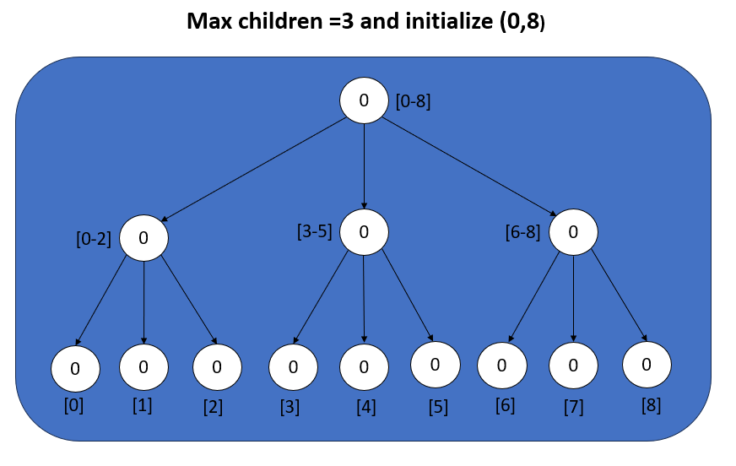
3.2.2 Flip function

- Recursively toggles (flips) the bit at a specified index by XOR the current data value with the provided value.
- If the current node is a leaf, it flips the bit by XOR data.
- For non-leaf nodes, it propagates the flip operation down to the child node covering the index.
- After updating the child, it recalculates the data field of the current node based on its updated children.
If you flip the bit at index=3, only the parity of its segment ([3,5]) and the root node ([0,7]) will change.
This ensures efficient updates in O(log n).

DPP* flip(DPP* node, int beg, int end, int index, int value)
{
if (!node) return nullptr;
if (beg == end)
{
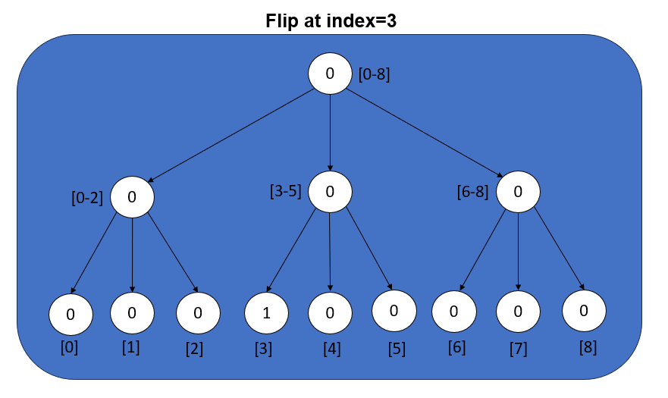
node->data ^= value;
node;}

3.2.3 Prefix parity calculation

- Recursively calculates the cumulative XOR (prefix parity) up to a specified index.
- If the index is outside the segment range represented by the node (index < beg), it returns 0.
- If the segment is entirely within the range [beg, end] <= index, it returns node->data.Otherwise, it recursively calls itself for the relevant child nodes that contain or overlap with the index until reaching the leaf nodes.
- prefix_parity(root, 0, n - 1, i) computes the cumulative XOR for elements up to index i, using the updated data values after the flip operations.
- This allows efficient calculation of prefix parities by avoiding a full traversal of the array each time, using the tree structure instead. index until reaching the leaf nodes.

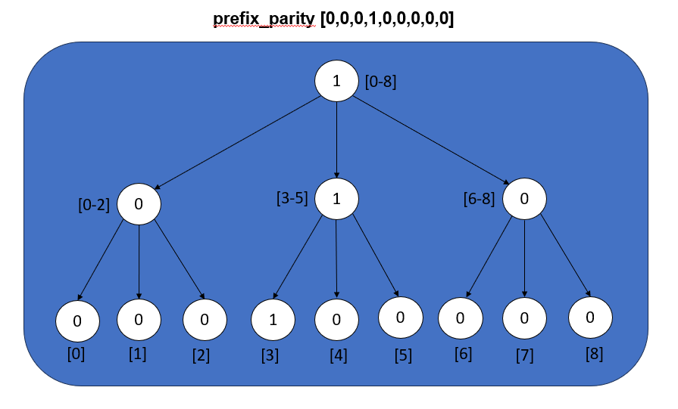

Calculation:
- Prefix up to index 0: Only includes [0], so parity is 0.
- Prefix up to index 1: Includes [0] and [1].
XOR = 0 XOR 0 = 0
- Prefix up to index 2: Includes [0], [1], [2].
XOR = 0 XOR 0 XOR 0 = 0.
- Prefix up to index 3: Includes [0], [1], [2], [3].
XOR = 0 XOR 0 XOR 0 XOR 1 = 1.
- Prefix up to index 4: Includes [0], [1], [2], [3], [4].
XOR = 0 XOR 0 XOR 0 XOR 1 XOR 0 = 1.
- Prefix up to index 5: Includes [0], [1], [2], [3], [4], [5].
XOR = 0 XOR 0 XOR 0 XOR 1 XOR 0 XOR 0 = 1.
- Prefix up to index 6: Includes [0], [1], [2], [3], [4], [5], [6].
XOR = 0 XOR 0 XOR 0 XOR 1 XOR 0 XOR 0 XOR 0 = 1.
- Prefix up to index 7: Includes [0], [1], [2], [3], [4], [5], [6], [7].
XOR = 0 XOR 0 XOR 0 XOR 1 XOR 0 XOR 0 XOR 0 XOR 0 = 1.
- Prefix up to index 8: Includes all nodes.
XOR = 0 XOR 0 XOR 0 XOR 1 XOR 0 XOR 0 XOR 0 XOR 0 XOR 0 = 1.

IMPLEMENTATION

CHAPTER 4

IMPLEMENTATION

4.1 STANDARD LIBRARIES

#include<iostream> - This directive includes the input/output stream library in C++, allowing the use of std::cin for input and std::cout for output. This enables interaction with the user through the console for reading and displaying data.

#include<cmath> - This directive includes the C++ math library, which provides a wide range of mathematical functions for performing operations such as trigonometry (sin(), cos()), power and square root calculations (pow(), sqrt()), logarithms, and more
.
Using namespace std - directive tells the compiler to use the standard C++ library's namespace. It simplifies code by allowing direct access to standard library features without the std:: prefix.

4.1.2 Initialization Module

This module creates the DPP tree by recursively dividing the range of bits into smaller subranges. Each node in the tree represents a segment of the bit array and stores the XOR (parity) of the bits in that segment.

Steps:
1. Determine the number of children based on the size of the current range.
2. Divide the range into balanced segments.
3. Recursively initialize each child node for the respective segment.
4. Compute the XOR of all children and store it in the current node.

Why it is important?

The DPP tree structure enables efficient prefix parity queries and updates by reducing the problem size at each level of the tree.

4.1.3 Flip Operation Module (flip)

This module updates the value of a bit at a specific index and recalculates the XOR values for all affected nodes in the DPP tree.
Steps:
- Traverse down the tree to find the leaf node corresponding to the index.
- Update the bit value by toggling it using XOR (node->data ^= value).
- Propagate the change back up by recalculating XOR values at each parent node.
Why it’s important?
Efficient updates allow us to modify bits in the array without recomputing the entire prefix parity.

4.1.4 Prefix Parity Module (prefix_parity)
This module calculates the XOR of all bits up to a specified index. It traverses the DPP tree to sum up the contributions of relevant subranges.
Steps:
- Check if the current node’s range is fully within, partially overlaps, or is outside the desired range.
- If fully within, return the XOR stored at the node.
- If overlapping, recursively compute parity by exploring relevant child nodes.
- Combine the results using XOR.
Why it’s important?
Efficient queries allow us to retrieve parity information for any prefix without traversing the entire bit array.

Approach | Time complexity | Number of operations | Memory usuage | Efficiency
Dynamic prefix parity | O(log n) for  Prefix queries,O(log n) for updates . | Dependent on the number of bits (n). | O(n) for storage of the tree structure. | Efficient for frequent updates and queries in large datasets.

4.1.5 Display the results
void displayResults()
{ cout << "Bit array: ";
for (int i = 0; i < n; i++)
cout << getPrefixParity(i) % 2 << " ";
cout << endl;
cout << "Prefix parities:" << endl;
for (int i = 0; i < n; i++)
{
cout << "Prefix parity up to index " << i + 1 << " is " << getPrefixParity(i) << endl;
}
4.1.6 Overall flowchart

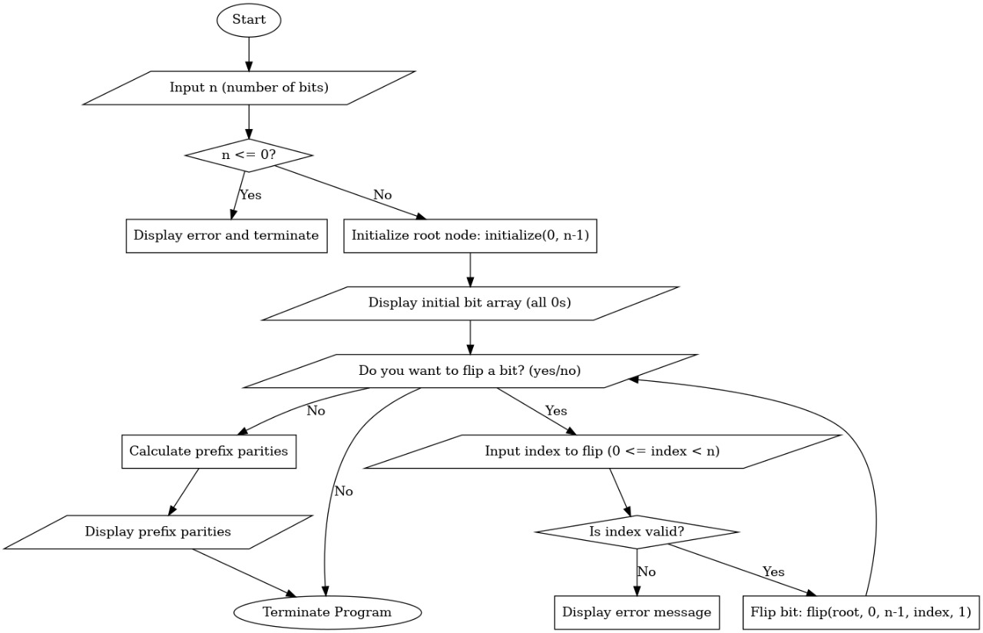

RESULTS AND DISCUSSION

CHAPTER 5

RESULTS AND DISCUSSION

5.1 SCREENSHOT

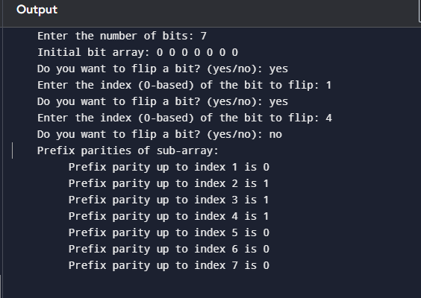

EXPECTED OUTPUT

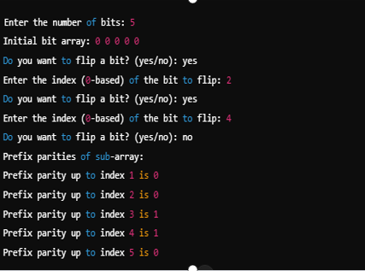

CONCLUSION

CHAPTER 6

6.1 CONCLUSION

The DPP program provides an efficient and modular implementation for managing and querying prefix parity in a dynamically structured bit array using a tree-based approach. Here's an overview of the key takeaways:

1. Modular and Scalable Design
- The program is built using object-oriented principles, encapsulating functionality within a DPP class for better reusability and maintainability.
- The modular design ensures scalability for handling larger input sizes.

2. Efficient Operations
- Initialization: Constructs a tree structure to represent the bit array, dividing it into segments. This ensures optimal performance for prefix parity calculations.
- Flip Operation: Dynamically updates the bit array by flipping a specific bit and recalculating parity only in the affected parts of the tree, avoiding unnecessary recomputations.
- Prefix Parity Calculation: Calculates the cumulative XOR values up to a given index efficiently, leveraging the tree's hierarchical structure.

3. Real-Time Interaction
- The program interacts with the user, allowing them to repeatedly flip bits and observe changes in the bit array and prefix parities.
- The results are displayed in a user-friendly format, demonstrating the dynamic nature of the prefix parity updates.

4. Practical Applications
- This implementation can be applied to real-time systems requiring efficient prefix computations, such as:
- Network error detection (using parity bits).
- Data integrity checks in storage systems.
- Efficient range queries in dynamic datasets.

5. Future Improvements
- Optimizing memory usage by dynamically allocating nodes only when necessary.
- Extending the program to support a wider range of operations, such as range updates or multiple parity computations.
- Incorporating parallelism for faster computations in large datasets.
The DPP program effectively demonstrates how tree-based data structures can handle dynamic updates and queries with high efficiency. It provides a strong foundation for exploring advanced applications in data structures, algorithms, and real-time systems.

Final Remarks
The Dynamic Prefix Parity (DPP) program is a robust and versatile implementation of a tree-based data structure that efficiently manages dynamic operations on bit arrays. By combining modularity, efficiency, and user interactivity, it highlights the importance of designing algorithms that can handle dynamic data updates and queries effectively.
Key highlights include:
1.Simplicity in Implementation:
- The design uses clear, structured modules for initialization, flipping, and prefix parity calculation, ensuring readability and maintainability
2.Efficiency in Operations
The hierarchical tree-based approach minimizes redundant computations, making it suitable for real-time applications requiring quick updates and range queries.
Real-World Relevance:
Applications span from error correction in communication systems to data verification in file storage and database indexing.
Future Scope:
Enhancements like parallel processing, support for multiple operations, and optimized memory usage can expand its applicability to larger datasets and more complex systems.
The DPP program is not only an excellent learning tool for understanding tree structures and dynamic programming techniques but also a foundational model for implementing efficient real-world data-handling systems. It demonstrates the power of thoughtful algorithm design and modular coding principles.

APPENDIX

CHAPTER 7
APPENDIX
7.1 CODE

#include <iostream>
#include <cstdlib>
#include <string>
#include <cctype>
using namespace std;

#define MAX_CHILDREN 3

struct DPP
{
int data;
int numChildren;
DPP* children[MAX_CHILDREN];

DPP(int value, int numChildren = 0) : data(value), numChildren(numChildren)
{
for (int i = 0; i < MAX_CHILDREN; i++)
children[i] = nullptr;
}
};

DPP* initialize(int beg, int end)
{
int range = end - beg + 1;
if (range == 1)
return new DPP(0);

int numChildren = min(MAX_CHILDREN, range);
DPP* node = new DPP(0, numChildren);

int segmentSize = range / numChildren;
int extra = range % numChildren;
int start = beg;

for (int i = 0; i < numChildren; i++)
{
int childRange = (i < extra) ? segmentSize + 1 : segmentSize;
node->children[i] = initialize(start, start + childRange - 1);
start += childRange;
node->data ^= node->children[i]->data;
}
return node;
}

int prefix_parity(DPP* node, int beg, int end, int index)
{
if (!node || index < beg)
return 0;
if (index >= end)
return node->data;

int range = end - beg + 1;
int numChildren = node->numChildren;
int segmentSize = range / numChildren;
int extra = range % numChildren;
int start = beg, parity = 0;

for (int i = 0; i < numChildren; i++)
{
int childRange = (i < extra) ? segmentSize + 1 : segmentSize;
int endRange = start + childRange - 1;

if (index >= start)
parity ^= prefix_parity(node->children[i], start, endRange, index);

start += childRange;
}
return parity;
}

DPP* flip(DPP* node, int beg, int end, int index, int value)
{
if (!node)
return nullptr;

if (beg == end)
{
node->data ^= value;
return node;
}

int range = end - beg + 1;
int numChildren = node->numChildren;
int segmentSize = range / numChildren;
int extra = range % numChildren;
int start = beg;

for (int i = 0; i < numChildren; i++)
{
int childRange = (i < extra) ? segmentSize + 1 : segmentSize;
int endRange = start + childRange - 1;

if (index >= start && index <= endRange)
node->children[i] = flip(node->children[i], start, endRange, index, value);

start += childRange;
}

node->data = 0;
for (int i = 0; i < numChildren; i++)
if (node->children[i])
node->data ^= node->children[i]->data;

return node;
}

int main()
{
int n;
cout << "Enter the number of bits: ";
cin >> n;

if (n <= 0)
{
cout << "Number of bits must be positive." << endl;
return 1;
}

DPP* root = initialize(0, n - 1);

cout << "Initial bit array: ";
for (int i = 0; i < n; i++)
cout << "0 ";
cout << endl;

string choice;
do
{
cout << "Do you want to flip a bit? (yes/no): ";
cin >> choice;

for (int i = 0; i < choice.length(); i++)
{
choice[i] = tolower(choice[i]);
}

if (choice == "yes")
{
int index;
cout << "Enter the index (0-based) of the bit to flip: ";
cin >> index;

if (index < 0 || index >= n)
cout << "Invalid index. Please enter a value between 0 and " << n - 1 << "." << endl;
else
flip(root, 0, n - 1, index, 1);
}
else if (choice == "no")
break;
else
cout << "Invalid input. Please enter 'yes' or 'no'." << endl;
} while (true);

cout << "Prefix parities of sub-array:" << endl;
for (int i = 0; i < n; i++)
cout << "Prefix parity up to index " << i + 1 << " is " << prefix_parity(root, 0, n - 1, i) << endl;

return 0;
}

REFERENCES

CHAPTER 8

  - REFERENCES

Introduction to Algorithms by Cormen, Leiserson, Rivest, and Stein (CLRS), Chapter 14 on binary search trees and Chapter 15 on dynamic programming.I.

Knuth, D. E., The Art of Computer Programming, Volume 3: Sorting and Searching.

- trees were originally introduced by Bayer and McCreight in their 1972 paper: Organization and Maintenance of Large Ordered Indices.

Method of Four Russians technique stems from the 1970 paper by Arlazarov, Dinic, Kronrod, and Faradzev: On Economical Construction of the Transitive Closure of a Directed Graph.

Algorithm Design Manual by Steven S. Skiena.

Data Structures and Network Algorithms by Robert Tarjan.

REAL TIME APPLICATION

CHAPTER 9

9.1 APPLICATIONS
1.Error Detection and Correction
In data transmission systems, dynamic prefix parity helps in real-time error detection. By maintaining and updating parity for prefixes of data packets, it is possible to verify data integrity dynamically during transmission
Cryptography
Dynamic prefix parity can be used in cryptographic algorithms for creating secure hash functions or random number generators where parity bits are used in key derivation or encoding.
- Stock Price Analysis:
In financial systems, prefix parity can be applied to compute metrics like the cumulative change in stock prices and determine whether the net changes result in an even or odd outcome.
Gaming (Checksum Validation)
Used in gaming systems for validating data integrity during multiplayer sessions or game state updates in real time.
Sensor Data Monitoring:
In IoT systems, prefix parity is used to track and validate the sequence of sensor data inputs, ensuring that the data is complete and uncorrupted as it streams.

Example Scenario
Use Case: Real-Time Data Integrity in a Sensor Network
A network of temperature sensors sends readings continuously to a central server. Each reading is a binary value representing whether the temperature crossed a certain threshold. The server uses dynamic prefix parity to verify the integrity of the incoming data:

Steps:
- Stream of Binary Data: The sensors send binary values (0 or 1) in real time.
- Dynamic Parity Calculation:
  - Prefix parity is maintained, updating with each incoming value:
    - Input: [0, 1, 1, 0]
    - Parity: [0, 1, 0, 0] (0 = even parity, 1 = odd parity)
- Real-Time Updates:
  - If a sensor reading changes, the prefix parity adjusts efficiently without recalculating from the beginning.
- Data Integrity Check:
  - The server compares the calculated parity with the expected value to detect errors.

Advantages of Dynamic Prefix Parity
- Efficiency: Updates are performed in O(1)O(1)O(1) time for a single value change.
- Scalability: Handles large data streams dynamically.
- Versatility: Can be applied across multiple domains requiring real-time updates and integrity checks.

